A.A. 2023/2024

Final Report

Report for Human Computer Interaction course project

Group name: User-Centered-Innovators  
Members: Alessandro Bianco, Elia Ferraro, Kevin Gjeka, Sylvie Molinatto

Contents

1. Introduction 3

2. Problem/Solution Overview 3

3. Needfinding 3

a. Domain description 3

b. Interviews 4

i. Methodology and procedure 4

ii. Results 6

c. Synthesis 8

i. Brainstormed user needs 8

ii. Deep user needs 11

d. Solutions 12

i. Solutions per deep user need 12

ii. Top Solution 13

4. Tasks and Storyboard 14

a. Task List 14

• Simple task: Select a destination and a time period. 14

• Moderate task: Insert needs and preferences to get a personalized itinerary. 14

• Complex task: Modify/Reschedule the trip plan. 14

b. Storyboard 15

5. Low-Fidelity Prototype 17

a. Modalities Exploration 17

b. Paper Prototypes 18

i. Realized prototypes 18

ii. Summary about connection between paper prototype and storyboard/tasks 23

iii. High-level flow diagrams 24

c. Heuristic Evaluations 25

i. Received Evaluation 25

ii. Violation report 27

d. Selection 35

6. Medium to High-Fidelity Prototype 35

a. Tool used 35

b. Link to Screens 36

c. Violation Resolution 36

7. High-fidelity Prototype 38

a. Tools and Frameworks 38

b. GitHub Repository 39

c. Significant Screens 39

• My Trips 39

• New Trip 39

• Trip Overview 42

d. Limitations 43

8. Usability Testing 43

a. Preparation and Run 43

i. Evaluation process 43

ii. Links 47

b. Results 47

i. Summarize 47

ii. What we discovered and learned 51

iii. List of potential changes 52

9. Conclusions 53

a. Main Learnings 53

b. Group Feedback 54

# Introduction

* **Project name**: **UrbanHUB**

We decided to call our project “UrbanHUB” because this name emphasizes the urban aspect of the project, making it clear that it's centered around city and urban travel, and suggests a central place or location for gathering information and resources. In the context of trip planning, it indicates that the project serves as a central hub for urban travellers to access everything they need. Indeed, the term 'urban' relates to cities and the associated infrastructure, services, and living environments. 'Hub' typically implies a central point or a place where various activities, services, or resources converge.

* **Value Proposition**: Inclusive and effortless urban travel
* **Team Members' Names**: Alessandro Bianco, Elia Ferraro, Kevin Gjeka, Sylvie Molinatto
* **Group Name**: User-Centered-Innovators

# Problem/Solution Overview

Through five interviews, our team identified key needs for trip planning, emphasizing the importance of quick and easy customization to individual preferences. Recognizing the significance of reliable and comprehensive information, as well as the flexibility to reschedule activities, we developed a solution. This solution involves utilizing surveys to gather user preferences, aiming to create a centralized platform for tailored trip itineraries beyond generic recommendations. The project focuses on enhancing customization by allowing users to input requirements and preferences for a personalized travel experience.

# Needfinding

## Domain description

#### **Domain of interest**: **urban tourism** (national and international)

We decided to focus on the tourism domain because as the opportunity for leisure travel has become increasingly accessible, many people choose to explore new cities and experiences on a daily basis. The barriers encountered during a trip planning, while significantly reduced in recent years, continue to be an area of interest, as we can play a significant role in enhancing the experience. For this reason, it is interesting to understand the actual needs of travellers to develop applications that can improve the quality of travel planning experiences.

## Interviews

### Methodology and procedure

#### Interviewees:

All the participants we have chosen are young travellers (in the range 20-30 years old) who have experienced the planning of different trips in urban locations. By sharing their experiences, they allowed us to understand what the real needs of tourists are when they find themselves having to arrange a visit to a city. We conducted interviews with four immediate users and one extreme user.   
We decided to interview a person with mobility disabilities as an extreme user and we found Desiréè who needs a wheelchair to move. This turned out to be a good choice because it allowed us to better understand some important struggles during the planning phase.

No domain expert has been included in the project.

Here is a brief introduction of the participants:

1. **Sebastiano Callà**: 23-year-old student of Sant'Antonino di Susa, a small town near Turin. He is currently studying at ITS ICT Piemonte to become a Fintech Software Developer. He has a great passion for travel, and he has visited many cities including Paris, Madrid, Barcelona, Prague, Krakow, and Munich. His willingness to visit these cities leads him to plan all the activities he wants to do and therefore is a great candidate to understand what his needs are when he has to plan a trip to a city.
2. **Riccardo Perrero**: 25-year-old student at Polytechnic of Turin, currently studying Business and Management Engineering. He has a passion for blockchain and cryptocurrency. Riccardo has visited the main cities of Eastern Europe and prefers to visit them in a couple of days each to save money and time, allowing him to study during the week and travel more often.
3. **Alessandro Bafaro**: 24-year-old student at Bocconi University, currently studying politics and policy analysis. He has a passion for nature, excursions, and running. Alessandro fits the role of an average traveller who has had experiences in Europe’s most popular cities. He prioritizes eco-friendly means of commuting and can thus give us insight into what mindful users consider during their city visits.
4. **Alessandra Zambelli**: 23-year-old psychologist from Milan, currently working in Rome. She loves trying new experiences and meeting new people. Moreover, she enjoys traveling to cultural cities as well as naturalistic destinations. She tends to try typical dishes to fully understand the culture of local people.
5. **Desirèe Milan**: 20-year-old girl from Asti studying communication management in Turin. She enjoys cultural and fun travels but not relaxing ones. Despite needing a wheelchair for most of her trips, she has visited many cities, including Venice, London, Amsterdam, and Vienna. She has encountered numerous difficulties but has managed to overcome them.

#### Location and procedure:

Interviews were done either via Google Meet or in presence. The respondents signed a form for consent to the processing of the data provided by them. Each interview was conducted by two members of the group, one of whom asked the questions and the other who took notes of the answers. Sometimes there was even a third member to attend the interview.

#### Traveler’s questions:

1. General info (age, gender, residence, main cities visited, …)
2. Tell me 3 good and 3 bad aspects about trip planning.
3. Describe the best and the worst experience during a city visit.
4. How do you plan your city trip?
5. How do you move during a city trip and why?
6. How do you discover all the attractions to see during the city trip?
7. How do you get tickets for the attractions?
8. Tell me about your meals during the city trip.
9. Do you use tools during your planning? If so, describe them. If no, why?
10. Describe me a failure in a city trip planning and how did you manage to recover from it.
11. What are the most important factors you consider while planning a city trip?
12. What are the most crucial difficulties when planning a city trip?
13. What do you think about real-time information about local attractions or local experiences?
14. How would you improve your city trips?
15. How would you manage money and expenses during city trips?

#### Extreme users’ additional questions:

1. Tell me about your disability and challenges related.
2. Do you have any suggestions or recommendations for how trip planning services can better support disabled travellers?
3. How do you get information about accessibility of cultural attractions?

#### Team member roles:

For the 5 interviews, each of us took a different role so that everyone of us conducted and took notes for at least one interview, in detail our roles have been:

1. 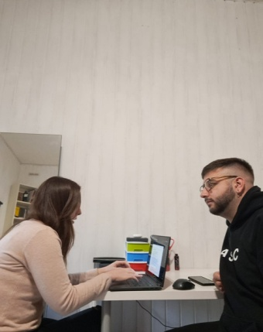Sebastiano Callà’s interview:

* Interviewer: Sylvie Molinatto
* Writer: Kevin Gjeka

1. 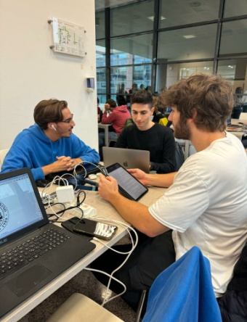Riccardo Perrero’s interview:

* Interviewer: Alessandro Bianco
* Writer: Elia Ferraro

1. Immagine che contiene Viso umano, uomo, persona, video

   Descrizione generata automaticamenteAlessandro Bafaro’s interview:

* Interviewer: Kevin Gjeka
* Writer: Alessandro Bianco

1. Immagine che contiene Viso umano, sorriso, persona, vestiti

   Descrizione generata automaticamenteAlessandra Zambelli interview:

* Interviewer: Elia Ferraro
* Writer: Sylvie Molinatto
* Attendant: Kevin Gjeka

1. Immagine che contiene Viso umano, testo, schermata, video

   Descrizione generata automaticamenteDesirèe Milan interview:

* Interviewer: Elia Ferraro
* Writer: Alessandro Bianco
* Attendant: Sylvie Molinatto

### Results

#### Key quotes:

1. **Sebastiano Callà**:

* One of the positive aspects of organizing trips is customization, which allows you to tailor the entire trip to your needs, choosing places that interest you the most.
* Another positive aspect is cost control, the ability to manage the entire trip cost in detail.
* Unexpected events are the worst aspect, in my opinion, as even a single unexpected event can disrupt the entire trip.
* Time constraints can also be a negative aspect because it never seems like there's enough time.
* Usually, before visiting a city, I look at various maps, check the websites of museums and other attractions, and I compile a list of all the attractions I want to visit.

1. **Riccardo Perrero**:

* I look for all the attractions that I want to visit on the map, and I plan to visit everything so that I waste as little time as possible.
* At first, I look for some special event in the city. Then, if I've already visited that city, I try to visit some attraction that I have never seen before.
* I set a full holiday budget and also a day-by-day budget, so that I can try to limit the expenses.
* Real-time information, if accurate, could be very useful to plan the trip and organize myself.
* I found one of the museums that I planned to visit closed. Unfortunately, I hadn't checked anything online before going in place because of my laziness.

1. **Alessandro Bafaro**:

* Planning a trip can be a long and tedious activity. Once you're done with the list of things to do, you move on to booking transports and visits in advance.
* I browse the internet to compile a list of attractions and then order them by priority, based on the price, commuting time, and the interest I have in each of them, considering time and budget constraints.
* A friend of mine booked the hotel for the wrong week. Found out the day before. Managed to book the correct week and get a reimbursement for the wrong reservation.
* I walk, use bike sharing, or rely on public transportation because it is more cost-effective than alternatives such as taxis or renting a car. Additionally, these methods are eco-friendly, require less planning, and are often faster ways of getting around.

1. **Alessandra Zambelli**:

* I was looking for a hostel with adequate reviews. I found one with good photos and I booked it. When I arrived, I found cockroaches and dirt everywhere. The information I had was terribly wrong.
* Google always proposes the same attractions for a specific city. I want to visit also unusual attractions beyond the most famous ones.
* I would use more specialized apps and websites to plan my trips, but they are too complex and time-consuming, so I only use social networks to find new attractions.
* I look for museums’ tickets online, but I always buy them directly at the counter because usually there are discounts not available in websites

1. **Desirèe Milan**:

* I was visiting Venice and I wanted to reach San Marco Square by boat but there was a ferry disruption, so I had to replan my trip and to struggle in narrow streets and on difficult stairs.
* I always check deeply the accessibility of all structures I want to visit. I use forums or special websites to do that. Sometimes, when I am in the building, I notice that many obstacles are not signalled beforehand on the websites. This happens even if I directly call the structure personnel for clarifications.
* I cannot change plans at the last minute because I need time to organize my trips from a place to another. I have to look for a transportation mean that can carry the wheelchair.
* I would like to book museums tickets online, but the websites never give the possibility to buy a reduced ticket for disabled persons. For this reason, I run the risk of not being able to enter.

#### What we learned:

Through the interviews we gained insights into effective communication strategies for gathering user feedback. We discovered the significance of establishing rapport to foster open dialogue and the importance of utilizing probing techniques to elicit comprehensive responses. Additionally, we recognized the value of employing active listening skills to fully understand participant perspectives and unearth valuable insights. Overall, our experience underscored the critical role of interpersonal skills and methodological rigor in conducting successful user interviews for informing design decisions.

## Synthesis

### Brainstormed user needs

#### The user needs to reschedule the trip in case of failure:

This need has been extracted from Sebastiano Callà’s answers to question number 2 “Tell me 3 positive and 3 negative aspects about trip planning” and question number 10 “Describe me a failure in a city trip planning and how did you manage to recover from it”.

#### The user needs to be able to adjust a trip schedule in case of failure:

This need has been extracted from different interviews:

1. Sebastiano Callà’s answer to question number 2 “Tell me 3 positive and 3 negative aspects about trip planning”.
2. Desirèe Milan answer to question number 3 “Describe the best and the worst experience during a city visit.”

#### The user needs to get reliable and complete information from his source/sources:

This need has been extracted from different interviews:

1. Riccardo Perrero’s answer to question number 6 “How do you discover all the attractions to see during the city trip?”
2. Alessandra Zambelli’s answer to question number 6 (previously reported) and question number 9 “Do you use tools during your planning? If so, describe them. If no, why?”

#### The user needs to manage the entire trip cost in detail:

This need has been extracted from different interviews:

1. Alessandro Bafaro’s answers to question number 11 “What are the most important factors you consider while planning a city trip?” and 15 “How would you manage money and expenses during city trips?”
2. Sebastiano Callà’s answer to question number 2 “Tell me 3 positive and 3 negative aspects about trip planning”.
3. Riccardo Perrero’s answer to question number 15(previously reported)

#### The user needs to be able to discover unusual attractions, which are not the most visited and known ones:

This need has been extracted from Alessandra Zambelli’s answer to question number 6 “How do you discover all the attractions to see during the city trip?”

#### The user needs to be able to organize the trip in a faster and simple way:

This need has been extracted from different interviews:

1. Alessandra Zambelli’s answer to question number 9 “Do you use tools during you planning? If so, describe them. If no, why?”
2. Sebastiano Callà’s answer to question number 12 “What are the most crucial difficulties when planning a city trip?”
3. Alessandro Bafaro’s answer to question number 14 “How would you improve your city trips?

#### The user needs to tailor the entire trip to his interests and budget:

This need has been extracted from Sebastiano Callà’s answer to question number 14 “How would you improve your city trips?”

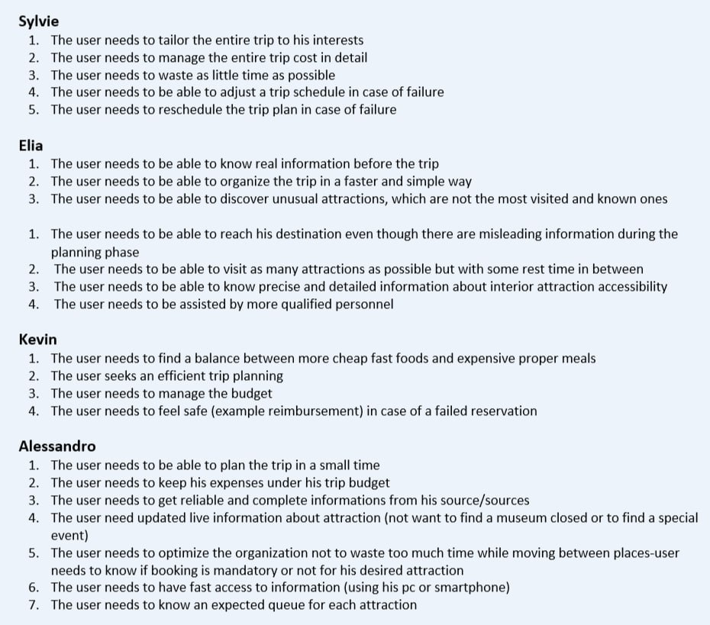

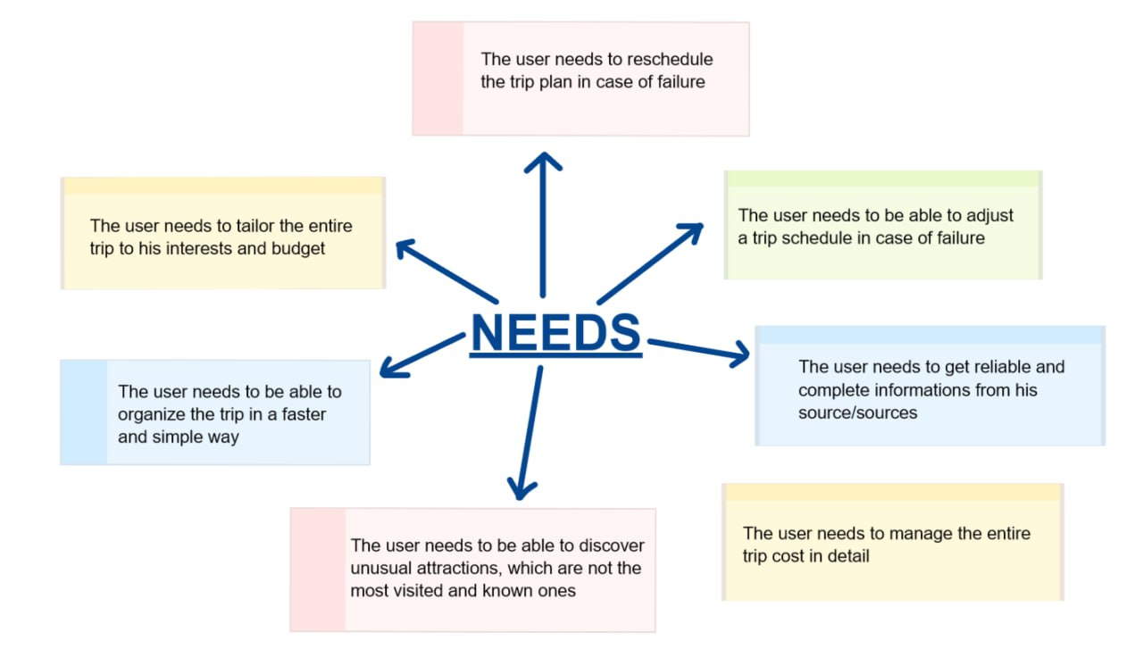

### Deep user needs

#### Personalize: the user needs to tailor the entire trip to his interests and expenses budget.

This user need has been selected because it is a crucial point when planning an urban trip, and this has been highlighted by more than one of the interviewed people. Answering to the questions Alessandra said: “By planning my trips, I can choose and filter only the attractions I prefer.” and Sebastiano answered with: “Planning a trip is a cost-free activity that is enjoyable and encourages creativity in designing a customized trip that suits your needs.”

#### Fast: the user needs to be able to organize the trip in a faster and simple way.

One of the points common to almost all interviews is that urban trip planning has to be fast, as Alessandra said: “Planning a trip can be a long and tedious activity when you are done with the list of stuff to do and moved on to booking transports and visits in advance.”

#### Reliable: the user needs to get reliable and complete information from his source/sources.

Another common point to several interviews is the need of reliable information regarding attractions, as Riccardo pointed out with his answer “Often, looking on Internet, different websites tell different things”. So, to solve this problem, our application needs to be a reliable source of information.

#### Reschedule: the user needs to reschedule the trip plan in case of failure.

Two over five of the interviewed people pointed out the need to be able to reschedule the trip in case of failure or if user changes his mind about something in the provided scheduling. Sebastiano said “Real-time information is extremely useful as it keeps you updated on local evens, sudden openings, and closures. This allows for better adjustment of your itinerary to make the most of your trip.”, and Desirèe shared a personal experience, mentioning, “I was visiting Venice and I wanted to reach San Marco Square by boat, but there was a ferry disruption, so I had to replan my trip and to struggle in narrow streets and difficult stairs...”

## Solutions

### Solutions per deep user need

After identifying the four primary user needs thorough interviews and brainstorming, our team convened for a comprehensive meeting aimed at exchanging ideas regarding potential solutions. This collaborative session allowed each team member to contribute their perspectives and insights, cultivating a creative and dynamic environment. As a result of our collective discussion, we were able to get multiple solutions tailored to address each identified need effectively. These solutions represent a culmination of our collaborative efforts and reflect our commitment to developing user-centric solutions that meet the diverse needs of our target audience. The solutions for each need are the following:

* **Personalize and fast**:

1. **Survey to understand user preferences and create the itinerary accordingly**:

This solution can make the urban trip planning more efficient, since surveys usually don’t take too much time, and allow to gather all the needed user preferences to be able to personalize the trip experience.

1. **Meetings with people who share similar interests to share their travel experiences**:

This solution allows to make users get useful information about trips that may interest them according to past experiences of other people, that would make planning for future trips easier and faster.

1. **The user can purchase a smart box with various experiences to choose from:**

This solution is surely the fastest of the three provided ones, and anyway allows to personalize the trip in the sense that user can pick the smart box containing activities that he is more compatible with.

* **Reschedule**:

1. **A customer support service that can be contacted at any time:**

This solution allows users to be supported by an expert that can help to solve any issue encountered during trip or trip planning.

1. **Allowing local volunteers to help users in need:**

Local people can offer their free time to help tourists in difficulty adjusting their itinerary or helping them with public transports or any other possible problem encountered during the trip.

1. **Camera system to provide real-time information on attraction queues or the overall status**:

Cameras can allow user to have real-time information about the status or the queue of the desired attractions, so that users can monitor that information to be able to reschedule the trip accordingly.

* **Reliable:**

1. **3D tour of public places and attractions**:

This solution was especially designed for disabled people, enabling them to preview the attractions they are planning to visit and determine if there are sufficient services available to ensure their ability to move freely throughout the tour.

1. **Allow the user to get in touch with people who have already had the same experience for any question**:

Doing so, users can ask for clarifications about any doubt they have to people that have already experienced the same attraction, in order to get fresh and reliable information.

1. **Camera system to provide real-time information on attraction queues or the overall status**:

Previously described.

1. **Site inspections carried out by authorized and reliable individuals regarding the state of the activities offered to the user**:

By implementing this solution, information about attractions can be regularly updated and verified by an accredited source. This would allow users to receive also trusted information.

### Top Solution

* The proposed solution involves utilizing surveys to gather information about users' preferences and constraints, thereby facilitating the tailoring of the suggested itinerary to align with individual needs. The aim of the project is to ensure a level of customization that goes beyond generic recommendations. Consequently, the project consists of creating a centralized platform where users can input their requirements and preferences, allowing them to receive a tailored trip itinerary.

We decided to pick this solution after having talked to each other during laboratory classes and evaluated each of the previously discussed deep user need, in order to get a solution that can accommodate many of them.

# Tasks and Storyboard

## Task List

### Simple task: Select a destination and a time period.

Entering a destination and a time period is a straightforward and commonly performed task. Users are typically familiar with inputting information, and it requires minimal decision-making. The task involves a simple action, and users are guided by prompts to enter the desired city and dates. The simplicity lies in the familiarity of the action and the clarity of the user's goal.

### Moderate task: Insert needs and preferences to get a personalized itinerary.

This task involves a moderate level of complexity due to the additional decision-making and customization required. Users need to articulate their specific interests, set a budget, and initiate the generation of a personalized itinerary. While it's user-friendly, it introduces more variables and preferences, making it moderately complex. The app's ability to process these inputs and generate a tailored itinerary adds a layer of sophistication.

### Complex task: Modify/Reschedule the trip plan.

Modifying or regenerating an itinerary introduces complexity as it requires users to interact with an existing plan. Users may want to adjust specific details, durations, or add/remove activities, necessitating a more advanced level of interaction. The app needs to handle dynamic changes to the itinerary intelligently. Complexity arises from managing multiple components of the itinerary and ensuring seamless adjustments without disrupting the overall coherence of the plan.

**Storyboard

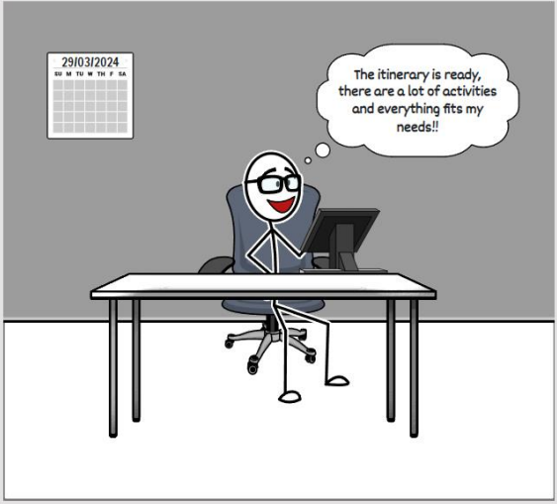

We opted to utilize a simple storyboard to maintain clarity. This choice underscores our dedication to presenting intricate details in a clear and easily understandable manner. The creation of this storyboard aligns with the core values of UrbanHub: simplicity, efficiency, and personalization. By comprehending the genuine needs of our users and crafting a narrative that reflects their experiences, our goal is to offer a travel planning solution that seamlessly integrates into their lives.

The storyboard presents 2 weaknesses:

* **Limited context**: the scenario is somewhat limited in scope, focusing solely on the protagonist’s need for a last-minute trip. It may not capture the diversity of user scenarios and requirements.
* **Simplicity over details**: while simplicity is a strength, the storyboard may lack depth in showcasing the intricacies of UrbanHub's features. It provides a high-level overview but may not cover all functionalities.

and 3 strengths:

* **User-centric approach**: the storyboard effectively portrays a user-centered scenario, emphasizing the protagonist’s real-world problem and need for a quick and stress-free trip planning solution.
* **Clear flow of tasks**: the tasks (entering a destination, providing interests, and modifying the itinerary) are presented in a logical sequence, making the user journey easy to follow.
* **Personalization highlighted**: the storyboard emphasizes the personalization aspect, showcasing how UrbanHub tailors the itinerary based on the protagonist's preferences and constraints.

In this storyboard, all the three tasks have been shown, in fact we can see the simple task in picture 4, the moderate task in picture 5 and the complex one in picture 7.

Overall, the storyboard successfully achieves the identified goals and user needs. It creates a narrative that resonates with users, showcasing the app's ability to personalize, operate swiftly, adapt to changes, and provide trustworthy information. This positions UrbanHub as a user-friendly and efficient solution for urban travel planning.

# Low-Fidelity Prototype

## Modalities Exploration

Moving from theory to practical implementation, our team delved into ways to give substance to our concepts, with a particular emphasis on integrating Artificial Intelligence. We explored several options:

* A **mobile app** emerged as strong choice due to the widespread use of smartphones.
* Another option under consideration was a **website** that calculates itineraries based on user-provided responses.
* We explored the feasibility of a **chatbot** because it provides an intuitive and inclusive interaction method with the system.

After a thorough evaluation, our team decided to exclude the chatbot. Although it is intuitive and inclusive, there were concerns about its ability to handle the extensive information needed to plan a personalized trip based on user preferences. Additionally, there were worries about its compatibility with the significant data load our centralized platform must generate for users. As a result, we have chosen to focus on the mobile-based application and the web application as our preferred modalities.

Selected alternatives motivation:

* **Web application**: the utilization of a web application stands as a viable option, given that it gives us more visual space to work with. Unlike other platforms, a web application offers expansive real estate, allowing us to present information, features, and interactive elements more effectively. Our conceptualization for this particular solution involves the incorporation of artificial intelligence (AI) capabilities. Specifically, we intend to integrate AI functionalities to generate pertinent questions and assess user responses systematically. This proactive approach will precede the presentation of the proposed itinerary to ensure a tailored and well-informed travel plan for the user.
* **Mobile-based app**: according to what we gathered from interviews, people seem to have interest in a fast and easy way to plan an urban trip, so the mobile app is one of the best choices for that objective. The fastest way for a user to communicate with a system is using his voice, so we decided to exploit the AI to recognize the user preferences from a vocal recording. Indeed, voice interaction can offer a convenient and inclusive way for users to provide their preferences and limitations. Users can verbally express their needs, such as accessibility requirements or sensory preferences, in a natural and efficient manner. Voice technology, coupled with natural language processing, can quickly gather user input and tailor trip suggestions accordingly.

## Paper Prototypes

### Realized prototypes

* **Web application**: in this first prototype, the user has the possibility to create a new trip or to view/edit an existing one in a web-based application. Let’s analyse in detail all the screens:

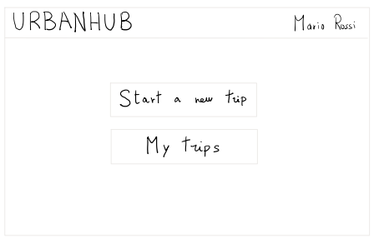

This is the home page of the application, here the user has the possibility to create a new personalized trip clicking the “Start a new trip” button, or to see the already created trips clicking the button “My trips”.

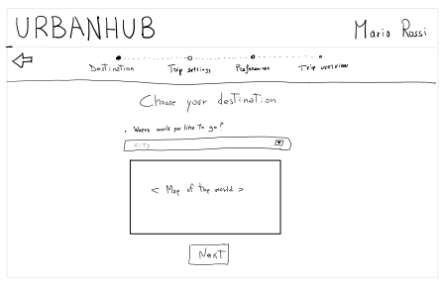After having clicked the “Start a new trip” button, this page is displayed, and the user here has the possibility to choose a destination and see it displayed in the map. The input field will show the possible cities while the user is typing to help him and avoid errors during the procedure. (you can see the described behaviours in the two following pictures).

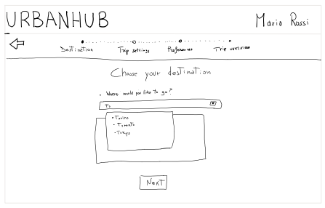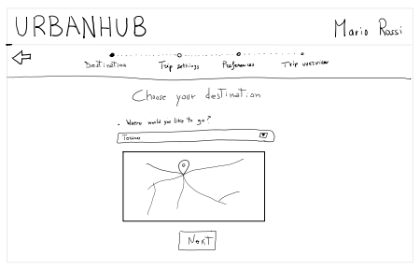On the next page, which appears after selecting the destination and clicking the “Next” button, users will be prompted to provide additional general details about their desired trip. Specifically, they will be asked to input a date range, indicate the number of participants, and specify a budget. As shown in the accompanying images, the date range input is simplified using a date picker to minimize errors during data entry.

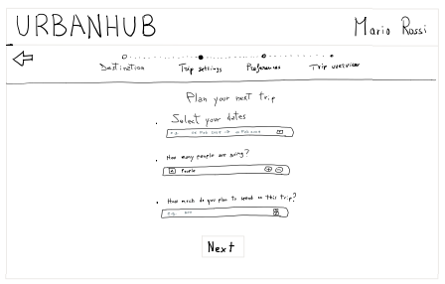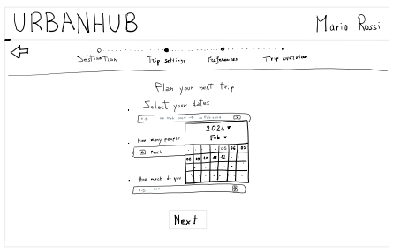

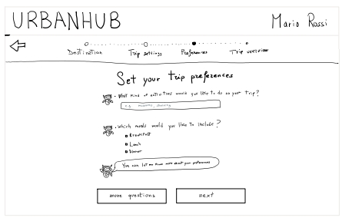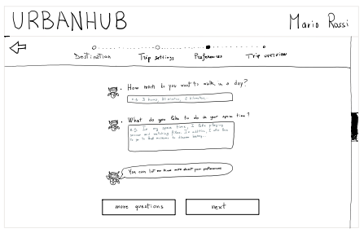Here again, after the click on “Next” button, the user will be asked to reply to some questions generated by the AI, this phase can be as long as the user wants, in the sense that he can request to receive more questions in order to get a more precise personalization, or he can click “Next” and see the generated trip.

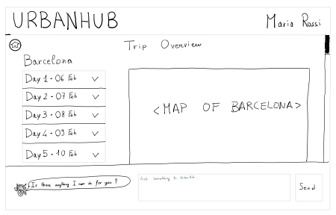After the user has responded to all the desired questions, the generated trip will be displayed in the trip overview page. Here, the user can view the per-day itinerary that has been selected according to his preferences, and the list of attractions along with the path to reach each of them is shown on the map to the right of the page. The user can interact with the chatbot placed at the bottom of the page to ask the AI to modify something in the provided trip schedule.

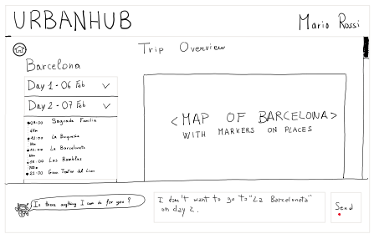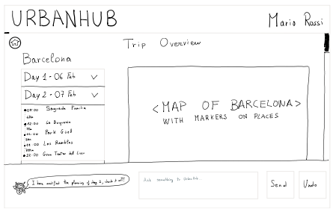

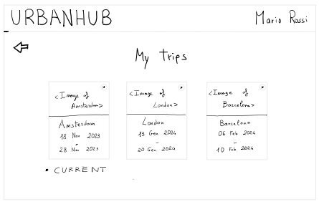

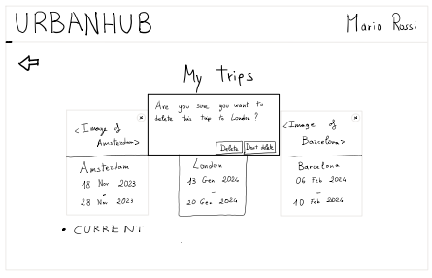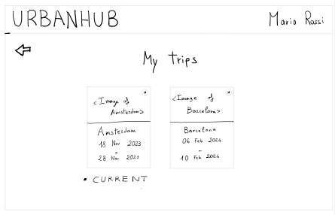If, instead of creating a new trip, the user clicks on “My trips” on the home page, this page is displayed. Here, all the trips previously created by the user are visualized, and the user can either click on the card to be taken to the overview page of the selected trip or click the “x” button in the top right corner of the card to delete the respective trip. Each card contains the general information needed to recognize the trip, particularly the visited city (or city to visit in the case of future trips) and the date range.

* **Mobile-based app**: in the second prototype, the user has the possibility to create a new trip or to view/edit an existing one in a mobile-based app. Let’s analyse in detail all the screens:

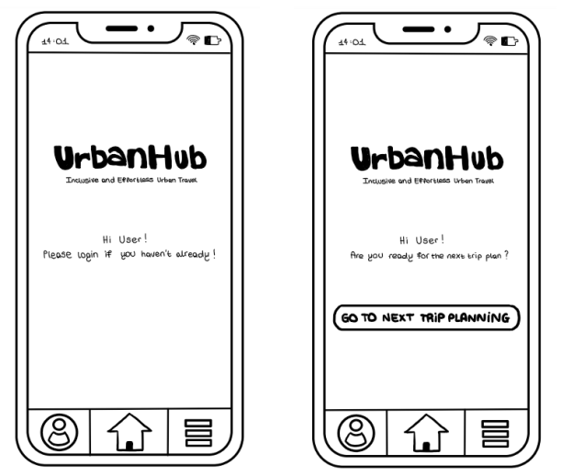

This is the page that the user sees when they open the app. There are versions available for both logged-in and not logged-in users. If the user is already logged in, they can click on “go to next trip planning” and start the creation process. If not logged in, they need to log in (procedure not handled) and then proceed.

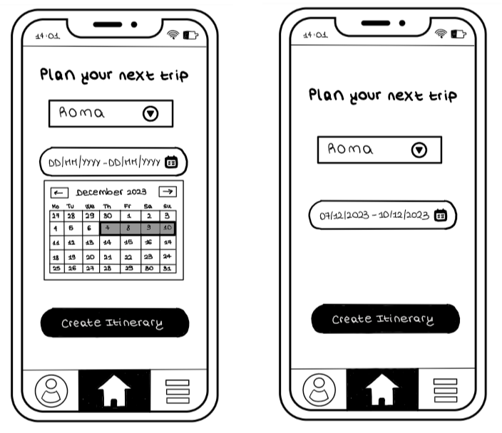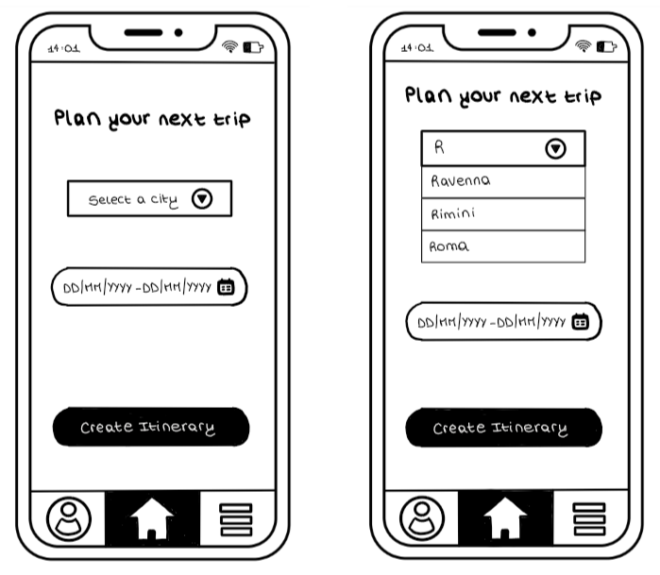By doing so, the user will be prompted to enter the destination of the trip and the date range. As shown in the following pictures, the input fields also offer facilitations to assist users during the insertion phase and prevent input errors.

After the user clicks on the “Create itinerary” button, the newly displayed page allows the user to express their preferences and interests using his voice. This helps in generating a truly customized itinerary based on the provided information. An information button is available to assist the user in understanding what to discuss during this phase. As shown, the user has the option to restart the conversation or confirm their choices.

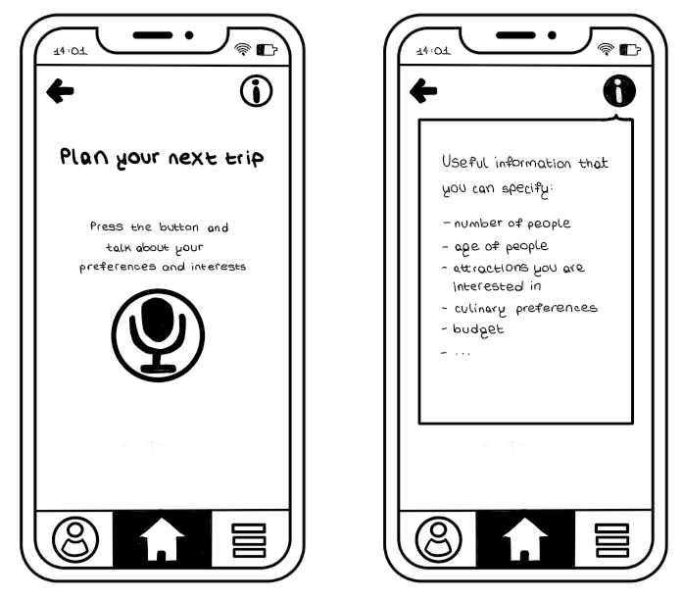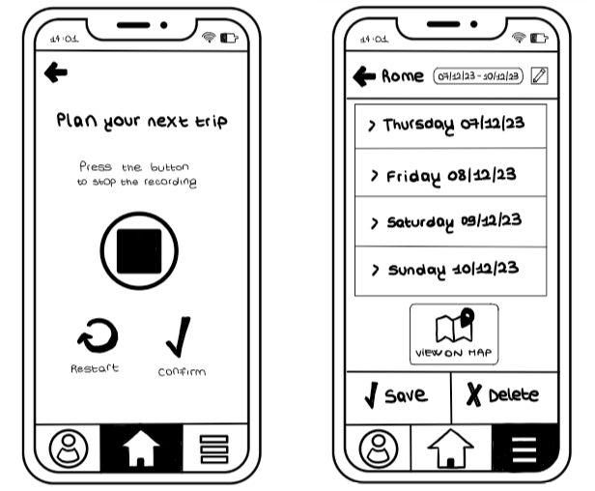

With the completion of the previous step, the AI will have all the needed information and will generate the proposed itinerary. At this point, the user will be able to overview the trip schedule with per-day itinerary and to modify that if necessary. The user can modify the duration of the trip, or the single day schedule. If he clicks on the “Edit” button, again the page with the possibility to talk to the AI will be displayed to accommodate user needs. At the bottom of the page there is the possibility to open the map to view the attractions, to save the trip or to delete it.

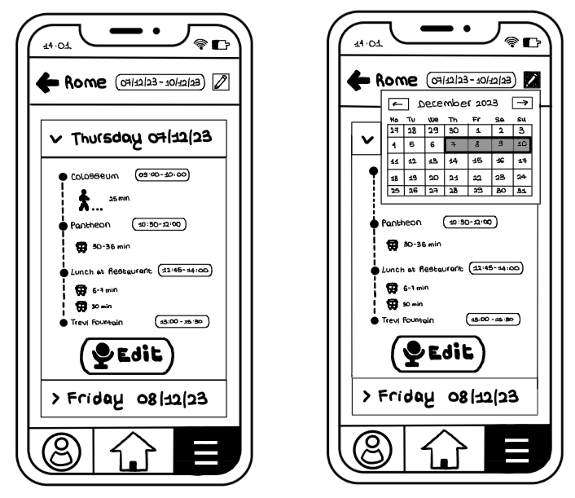

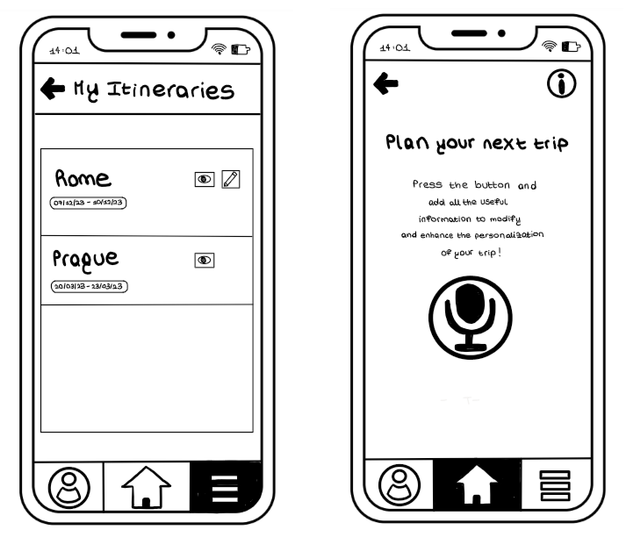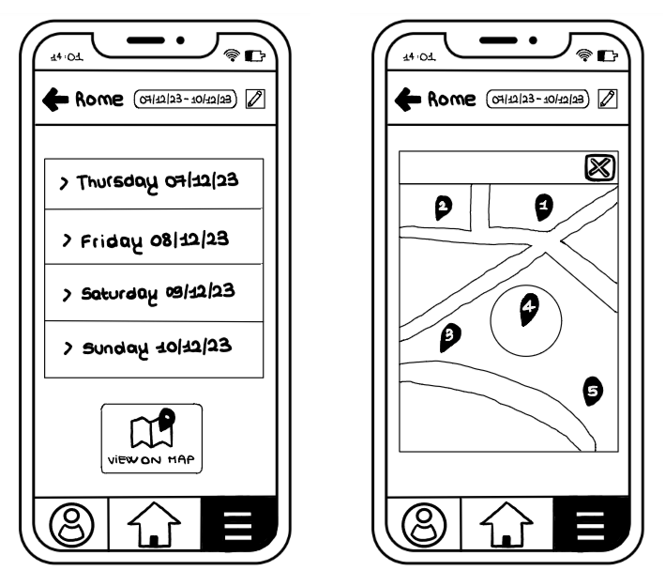In these pictures are shown the displayed pages in case of “Edit” or in case of “View on map” buttons are clicked.



And finally, this is the page where the user can view all existing trips and open them in either view or edit mode.

### Summary about connection between paper prototype and storyboard/tasks

In both previously described paper prototypes, users are empowered to craft a personalized urban trip itinerary swiftly and effortlessly, tailored to their preferences. As illustrated in the storyboard, users engage in inputting essential details such as the date range, destination, and preferences, subsequently receiving a bespoke itinerary that they can further modify to their liking. Notably, both provided prototypes effectively demonstrate the described function and behaviour, ensuring a seamless user experience. Moreover, all three tasks are successfully completed, in fact the user can decide the date range and the destination (simple task), insert his preferences (moderate task) and modify the received itinerary (complex task).

### High-level flow diagrams

* **Paper prototype #1**

For the first paper prototype we structured the high-level flow diagram considering the four main sections of the project. They are the homepage, the catalogue of all trips, the trip creation, and the trip overview. Starting from the homepage, the user can start the creation of a new trip or browse the existing ones. Then, from the list of trips the user can select a specific trip to open the relative trip overview page. The same page can be accessed after completing the entire process of trip creation by submitting all the needed information. While the user is in the trip overview page, he/she can also view details about trip and attractions and, if needed, he can also edit them. We want the user to follow a linear path while interacting with our product, to avoid mistakes and frustrations.

* **Paper prototype #2**

The general flow of the second paper prototype is very similar to the first one since, also in this case, there are all the four main sections (homepage, trip list, trip creation and the overview). The main differences are in the interactions that are mainly oral. Apart from the initial trip creation form, where the destination and the dates have to be inserted manually, all the other inputs are vocal. The main one is the selection of the preferences about a trip.

## Heuristic Evaluations

### Received Evaluation

Our project has been evaluated four times, two for each paper prototype. We organized the evaluations with a little explanatory introduction to present the general idea of the prototype and to communicate the three tasks. Then, the evaluator was given the freedom to navigate through the pages of the paper prototype by interacting with it through "clicking" and "typing" wherever desired. Simulating the system's behaviour was the responsibility of one member of the group.

Overall, the evaluations resulted in mostly positive outcomes. However, they were instrumental in identifying minor issues that could have caused problems during regular, everyday use of the products. These issues were often attributable to the fact that the evaluation was performed on a paper prototype, which lacks the precision of a medium-fidelity prototype.

For what concerns the first paper prototype, the main violations found are focused on the button placement and the visibility of the system status with the lack of confirmation messages. According to the second prototype, instead, the main issues were about the lack of functionalities like the undo one and the misleading behaviour of the back button.

Here's the final comments of the evaluators about our two prototypes:

#### **Paper prototype #1 (web application)**

**Evaluation 1:**

Evaluator: Samaneh Gharehdagh Sani (s309100)

Resume: In the heuristic evaluation, many usability issues were identified, particularly concerning system status visibility, user control, and consistency. Lack of a home button on certain pages, inconsistent button placements, and limited flexibility in budget adjustments were noted. While error prevention and recognition were commendable, enhancements are needed for better user control and a consistent experience. Recommendations include ensuring a consistent home button presence, refining button placements, and offering more flexibility in budget adjustments. Additionally, integrating user preferences directly into initial steps and AI capabilities for activity suggestions based on age can enhance efficiency and user experience.

<https://github.com/polito-hci-2023/User-Centered-Innovators/blob/main/Received%20euristic%20evaluations/309100-Smaneh-Gharehdagh-Sani%20(prototype%20%231).pdf>

**Evaluation 2:**

Evaluator: Federica Terramagra (s305777)

Resume: The platform demonstrates efficiency and clarity, especially regarding error prevention and system status visibility. However, improvements in flexibility and efficiency can be made by integrating preferences directly into initial steps and leveraging AI for more flexible date choices and activity recommendations based on age. Clarification is needed regarding how attraction modifications affect the timetable and how the AI handles deviations in attraction durations. Overall, while no major violations of Nielsen's heuristics were found, integrating AI and addressing flexibility issues can enhance the platform's usability and efficiency.

<https://github.com/polito-hci-2023/User-Centered-Innovators/blob/main/Received%20euristic%20evaluations/305777-Federica-Terramagra%20(prototype%20%231).pdf>

#### **Paper prototype #2 (mobile application)**

**Evaluation 1:**

Evaluator: LADRAT Mattéo (s321529)

Resume: The application is well-designed and understood, with minor areas for improvement in user experience. Enhancements are suggested primarily in error handling to provide users with more information and warnings, preventing unintended actions and facilitating progress, especially during longer journeys.

<https://github.com/polito-hci-2023/User-Centered-Innovators/blob/main/Received%20euristic%20evaluations/s321529-Matteo-LADRAT%20(prototype%20%232).pdf>

**Evaluation 2:**

Evaluator: Hossein Kakavand (s308581)

Resume: The mobile app prototype displays potential but requires enhancements in user interface and experience. Issues include limited user control, missing navigational elements, and insufficient system feedback. Recommendations focus on simplifying input methods, adhering to intuitive design principles, enhancing system feedback, and integrating user-centric features like language selection and offers for tickets and dining. These improvements, guided by usability heuristics, are essential for enhancing the app's appeal and functionality.

<https://github.com/polito-hci-2023/User-Centered-Innovators/blob/main/Received%20euristic%20evaluations/S308581-Hossein-Kakavand%20(prototype%20%232).pdf>

### Violation report

###### Here’s the list of violations of the first paper prototype:

1. **H2: Match between system and the real world**

*Where*: My Trips - Delete trip

*What*: Use of "Don’t Delete" for cancelling deleting a whole trip; it should be something like “Cancel”

*Why*: Consider using plain language and simple, recognizable terms that align with users' common knowledge and mental models.

*Severity*: 3

1. **H4: Consistency and standards**

*Where*: My Trips - Clicking on previous trips

*What*: The action of clicking on previous trips within the "My Trips" section lacks consistency and adherence to standards, as it results in an unintended consequence.

*Why*: According to established design standards, clicking on a previous trip should typically lead to a view-only mode, allowing users to review the details without the risk of unintentional modifications. However, in this instance, it appears that the action may lead to unintended modifications, violating the principle of consistency and user expectations.

*Severity*: 3

1. **H4: Consistency and standards**

*Where*: Trip overview

*What*: Typically, users expect the back button in this position on other pages.

*Why*: Inconsistencies in design elements can lead to user confusion; maintaining a standard placement would enhance user experience.

*Severity*: 3

1. **H3: User control and freedom**

*Where*: Plan your next trip - How many people are going

*What*: The app lacks the option to include kids (0-17 y/o) when adjusting the number of people.

*Why*: Fails to address families as potential users.

*Severity:* 3

1. **H4: Consistency and standards**

*Where*: Plan your next trip

*What*: The absence of a home button on this page departs from the expected consistency, as typically, a home button is anticipated to be present at the top of every page.

*Why*: Ensuring a uniform presence of the home button across all pages is crucial for maintaining a consistent and predictable user experience.

*Severity*: 3

1. **H4: Consistency and standards**

*Where*: Trip Overview - Delete Attraction

*What*: The confirmation prompt for deleting an attraction is on the left side of the window, contrary to the common practice of having it on the right in web applications.

*Why*: Deviating from established norms in button placement could cause confusion for users accustomed to standard web application interactions.

*Severity*: 2

1. **H1: Visibility of system status**

*Where*: Trip overview - add attraction

*What*: The system should display a message indicating that the attraction has been added and an updated view of their trip overview.

*Why*: This information should be presented in a visual and accessible manner, such as a pop-up window for the user to make sure that the modification has been done.

Severity: 2

1. **H1: Visibility of system status**

*Where*: My trips

*What*: The system should display a message indicating that the trip has been deleted successfully by clicking on Delete.

*Why*: This information should be presented in a visual and accessible manner, such as a pop-up window for the user to make sure that the modification has been done.

*Severity*: 2

1. **H4: Consistency and standards**

*Where*: Plan your next trip - How many people are going

*What*: The platform permits users to adjust the number of people, but the placement of the + and - buttons is reversed from the conventional user expectation.

*Why*: Inverting the button order deviates from established design standards, potentially causing confusion for users.

*Severity*: 2

1. **H1: Visibility of system status**

*Where*: Trip overview - is there anything I can do for you

*What*: The system should display a message indicating that the Message sent successfully by clicking on send.

*Why*: This information should be presented in a visual and accessible manner, such as a pop-up window for the user to make sure that the modification has been done.

*Severity*: 2

1. **H2: Match between system and the real world**

*Where*: Plan your next trip - Heading

*What*: Instead of Plan your next trip as a heading, I prefer to use “Plan your trip”.

*Why*: It’s a current trip that the user is planning for not the next one.

*Severity*: 2

1. **H3: User control and freedom**

*Where*: Choose your destination

*What*: The app doesn’t have any “Cancel” to exit planning for a new trip.

*Why*: Clearly label and place "Cancel" buttons in the user interface, so the user quickly understands how to exit or return to a previous stage.

*Severity*: 2

1. **H3: User control and freedom**

*Where*: Plan your next trip - Which meals would you like to include

*What*: Limited meal options provided (breakfast, lunch, and dinner) without considering other possibilities like morning or afternoon caffe or snacks.

*Why*: Given the diverse culinary offerings in various cities, integrating additional options aligns with the platform's AI capabilities, accommodating user preferences more comprehensively.

*Severity*: 2

1. **H4: Consistency and standards**

*Where*: Trip Overview - Add Attraction

*What*: The confirmation for saving an attraction is on the usual right-side placement in web applications.

*Why*: Consistency in button placement aids user familiarity and deviating from this standard may lead to confusion.

*Severity*: 2

1. **H7: Flexibility and efficiency of use**

*Where*: Preferences

*What*: While the platform allows users to address "more questions" related to preferences, a more user-friendly approach would involve integrating all preference options directly in the initial preferences step.

*Why*: Placing preferences in a dedicated box during the first step would streamline the process, eliminating the need to navigate to "more questions" and respond to potentially unnecessary queries.

*Severity*: 2

1. **H5: Error prevention**

*Where*: Trip Overview - Add Attraction

*What*: The system lacks a mechanism to prevent users from selecting time-consuming attractions that might be challenging to insert without modification.

*Why*: Implementing an error prevention feature would assist users in making more informed choices, avoiding the selection of attractions that could disrupt the scheduling process.

*Severity*: 2

1. **H3: User control and freedom**

*Where*: Plan your next trip - How much do you plan to spend on this trip.

*What*: The platform restricts budget adjustments to only increasing or decreasing 1 euro by 1 and lacking the option for specifying non-round numbers.

*Why*: Optimal user experience would involve allowing users to input their exact budget directly, avoiding inconvenience for those with specific, precise budget requirements.

*Severity*: 1

1. **H3: User control and freedom**

*Where*: Plan your next trip - Add attraction

*What*: When selecting the hour, the platform offers only half-hour time ranges.

*Why*: Users may prefer a more precise time selection to adhere to a strict timetable.

*Severity*: 1

1. **H6: Recognition rather than recall**

*Where*: Trip Overview - Add Attraction

*What*: The system showcases a list of the most viewed attractions based on the city and user input for preferred activities during the attraction addition process, demonstrating a commendable application of "recognition rather than recall”.

*Why*: This feature simplifies the user experience by presenting familiar options, derived from popular searches, eliminating the need for users to recall specific attractions.

*Severity*: 1

1. **H10: Help and documentation**

*Where*: Trip overview

*What*: The absence of direct links to websites for purchasing tickets is a missed opportunity for user convenience.

*Why*: Integrating direct links to ticket purchase websites in the trip overview would enhance user convenience by providing quick access to relevant information.

*Severity*: 1

1. **H7: Flexibility and efficiency of use**

*Where*: Trip overview - Add attraction

*What*: The design is not clear; it is a textbox but with the icon of a sliding window (v)

Why: It seems that you can select something from a list, but you have to write something beforehand. So, default options may speed-up the process

*Severity*: 1

1. **H4: Consistency and standards**

*Where*: Trip overview

*What*: The status bar is no longer present

*Why*: If it doesn’t affect the visibility of the whole page, it could be great to keep the status bar

*Severity*: 1

###### Here’s the list of violations of the second paper prototype:

1. **H3 User Control and Freedom**

Where: Sub-plan section

*What*: Sub-plans are currently not editable.

*Why*: Limits user control and ability to modify or correct plans.

*Severity*: 3

1. **H2 Match Between System and the Real World**

*Where*: Main interface

*What*: Lack of a menu bar on the page.

*Why*: Inconsistent with standard interface conventions, potentially confusing users.

*Severity*: 3

1. **H2 Match Between System and the Real World**

*Where*: General navigation

*What*: No home button designed.

*Why*: Defies common navigation conventions, hindering user orientation.

*Severity*: 3

1. **H1 Visibility of System Status**

*Where*: Error handling

*What*: No pop-up designed for errors.

*Why*: Fails to provide immediate feedback on errors, leaving users uncertain.

*Severity*: 4

1. **H5 Error Prevention**

*Where*: Plan creation

*What*: No offers for tickets to tourist places or eateries.

*Why*: Misses an opportunity to prevent user disappointment and enhance experience.

*Severity*: 2

1. **H3 User Control and Freedom**

*Where*: Plan management

*What*: No delete button to completely remove a plan.

*Why*: Limits user control over managing their plans.

*Severity*: 3

1. **H1 Visibility of System Status**

*Where*: Saving process

*What*: No pop-up message to confirm saving.

*Why*: Lacks clear feedback on action completion, leading to uncertainty.

*Severity*: 2

1. **H2 Match Between System and the Real World**

*Where*: App initialization

*What*: Absence of a language selection button on the first page.

*Why*: Does not cater to a diverse user base, hindering accessibility.

*Severity*: 3

1. **H7: Flexibility and efficiency of use**

*Where*: On the page to list created trips

*What*: There is no button to easily access the page to create a new trip

*Why*: This is not efficient because if the user sees from the list that a trip is missing, he has to go back to the home page to click on the button to add a new trip, whereas a simple button on the list could save him time and make the application more efficient.

*Severity*: 2

1. **H4: Consistency and standards**

*Where*: On the page to list created trips

*What*: The terminology used is different from the button used to access the page

*Why*: A difference in terminology can disrupt the user's browsing experience, telling him he's clicked in the wrong place. If the button is labelled "trip", the page should display "trips" and not "itineraries".

*Severity*: 1

1. **H4: Consistency and standards**

*Where*: Page to list created trips + page to create a new trip

*What*: The initial navigation bar disappears when you select an option on it

*Why*: In my experience, the navigation bar should be visible on all pages linked to a navigation element. For example, the bar should always be present on the trip list page and the trip creation page, since these pages can only be accessed from this navigation menu.

*Severity*: 1

1. **H4: Consistency and standards**

*Where*: Page to personalize the trip by voice

*What*: There is no indication that we should firstly click on “stop” before clicking on “restart” or “confirm”

*Why*: If the buttons are present but not clickable, a visual element should indicate that we can’t use it right now with a possible indication of the reason

*Severity*: 2

1. **H4: Consistency and standards**

*Where*: On the full form to create a new trip

*What*: The button on the navigation bar indicates that we will create a “NEW” trip but once we are on the page it says “NEXT” trip.

*Why*: A difference in terminology can disrupt the user's browsing experience, telling him he's clicked in the wrong place.

*Severity*: 1

1. **H4: Consistency and standards**

*Where*: On the page to select the city of the trip

*What*: The display of the input can be misleading

*Why*: The input is a text input where certain options are displayed according to the text entered (for example, if you press "R", you'll see "Ravenna", "Rimini" and "Roma" as options), while the icon suggests to the user that it's a drop-down list

Severity: 3

1. **H3: User control and freedom**

*Where*: On the page to plan the trip using the voice and more specifically the help pop-up

*What*: There is no visual indication on how to close the help pop-up

*Why*: The user should always be able to see quickly how to exit the current interaction

*Severity*: 3

1. **H1: Visibility of system status**

*Where*: On the page to plan the trip using the voice

*What*: While you're recording, there's no indication of what the system understands.

*Why*: If the trip is very long, the explanation can take some time and, as a result, errors on the part of the user or what the system understands can occur very often. Having visual information about what the system understands can help users to realize the error not at the end, but while they're talking.

*Severity*: 3

1. **H4: Consistency and standards**

*Where*: On the form to create a new trip

*What*: There are 3 steps, and there are 3 different buttons (label + design) to go to the next step

*Why*: It's important to maintain design consistency when we're working on the same functionality. So, in my opinion, having the same button to go from step 1 to 2 and from step 2 to 3 can be interesting. What's more, the button to validate the trip should also be similar or very different (not the same action).

*Severity*: 3

1. **H5: Error prevention**

*Where*: On the last page of the form to create a new trip

*What*: How to change the city isn’t clear while how to change the date is very clear

*Why*: A user who selects the wrong city and, as a result, obtains the wrong trip risks losing out on changing the city. They will click on the edit icon, but will only be able to change the date, not the city. Consistency in the editing behavior of these two elements (back to step 1) may be useful to avoid confusion.

Severity: 3

1. **H4: Consistency and standards**

*Where*: On the form to create a new trip

*What*: The behavior of the “Go back” button is misleading

*Why*: On the first step, the go back leaves the form but then, on the other pages, it allows going back to the previous step. But the end of the form, where you can edit the information entered at step 1, lets the user think that you can’t go back between steps. At the same time, what happens to the data? Is it retained? Deleted? Is there an error or a message to warn of the impact?

*Severity*: 4

1. **H5: Error prevention**

*Where*: On the form to create a new trip where you can edit the date after indicating all the steps by voice

*What*: No prevention against the loss of information for deleted dates

*Why*: Changing the date from "12-20-2023 to 12-27-2023" to "12-20-2023 to 12-25-2023" does not result in any prevention by means of a message or other means, whereas you lose the information relating to the 26th and 27th (deleted days).

*Severity*: 3

1. **H7: Flexibility and efficiency of use**

*Where*: On the pop-up to show the itinerary trip of the day

*What*: The map doesn’t give more information than the list and should display the path between steps

*Why*: In my opinion, the use of a map is more to know the path between steps instead of simply showing the location of each step.

*Severity*: 2

1. **H9: Help users recognize, diagnose, and recover from errors**

*Where:* On the form to create a new trip where you can edit the date after indicating all the steps by voice

*What*: There is no way to undo a change at the end of the form

*Why*: Changing the date from "20-12-2023 to 27-12-2023" to "20-12-2023 to 25-12-2023" will result in the loss of data for the 26th and 27th, but if this is an error, you won't be able to undo the action. At the same time, if you use the "modify" function to delete a step from a defined day, you may encounter the same problems where several steps are deleted, but you can't undo the action.

*Severity*: 3

1. **H7: Flexibility and efficiency of use**

*Where*: On the page to select the city of the trip

*What*: There is no indication of the country where the city is

*Why*: If two cities have the same name in different countries, this may cause confusion for the user looking for the city in question, so displaying the country associated with the city may make the search easier. However, if the application is for Italy only, this information should be displayed somewhere else, if not next to the city.

*Severity*: 2

## Selection

We opted to proceed with the **web application** (first prototype) for our app instead of the mobile version due to several strategic considerations. The desktop environment offers a larger canvas that allows for more expansive and detailed user interfaces, enhancing the overall user experience. Additionally, certain features and functionalities, such as the map visualization, are better suited for desktop interactions, providing users with a more robust and immersive interaction. Moreover, considering the nature of our app and the three tasks we selected, the desktop platform aligns well with the complexity and depth of our content, ensuring optimal usability and efficiency.

# Medium to High-Fidelity Prototype

## Tool used

We used ***Figma*** to design our medium-fidelity prototype because it is the best solution with a lot of online resources to start the design process.

We selected, as the two main screens, the page of trip preferences and the trip overview page. They are the pages where the user is required to interact in a deep way with the system. In addition, many means of interaction are possible, since these pages contain buttons, text areas, accordions, and maps. These two pages are the most critical ones in terms of interactions, so it is better to have a medium-fidelity prototype of them before switching them into a high-fidelity prototype, in order to avoid problems.

## Link to Screens

This is the link to the Figma project of the two screens:  
<https://www.figma.com/file/pkAuoyPOHI3BHn0qWmBATN/Urban-Hub-medium-fidelity-prototype?type=design&node-id=0-1&mode=design&t=yQORzHHWI8meKvdU-0>

## Violation Resolution

###### Plan for the hi-fi prototype:

1 - H2: Match between system and the real world

* Rename the action button from "Don’t Delete" to a more intuitive "Cancel" to align with users' expectations and promote straightforward understanding. (Already visible in medium fidelity prototype)

3 - H4: Consistency and standards

* We will replace the home button with the arrow back button to be consistent.

4 - H3: User control and freedom

* We will include, in the trip settings page, an option to adjust the number of children (0-13 y/o), to address the needs of families and provide comprehensive user control.

6 - H4: Consistency and standards

* Adjust the placement of the delete icon on the right of the component. (Already visible in medium fidelity prototype)

7 - H1: Visibility of system status

* Implement a visual message display indicating that the attraction has been added, accompanied by an updated view of the trip overview for immediate user feedback. (Already visible in medium fidelity prototype)

8 - H1: Visibility of system status

* Display a visual message confirming the successful deletion of a trip when the user clicks on Delete, providing clear system status feedback.(Already visible in medium fidelity prototype)

9 - H4: Consistency and standards

* Adjust the placement of the + and - buttons to align with conventional user expectations, ensuring consistency in design elements. We will use a predefined component.

10 - H1: Visibility of system status

* We will modify the send button to contain a message indicating that the message has been correctly received by the bot. (Already visible in medium fidelity prototype)

11 - H2: Match between system and the real world

* Change the heading to "Plan your trip" to accurately reflect that the user is planning the current trip, not the next one.

14 - H4: Consistency and standards

* We will swap the 'Save' and 'Cancel' button in the deletion popup. (Already visible in medium fidelity prototype)

16 - H5: Error prevention

* We will display the typical time expense for the selected attraction but we cannot force the user to spend all the time in that attraction. So maybe he can plan to see the attraction at strange time slots.

17 - H3: User control and freedom

* We will use a component which has the possibility to handle float numbers.

18 - H3: User control and freedom

* We will use predefined components to select the time. They will have the possibility to handle specific, not rounded, time slots.

21 - H7: Flexibility and efficiency of use

* Redesign the textbox and icon to improve clarity, ensuring users understand that they need to write something beforehand and providing default options to expedite the process. (Already visible in medium fidelity prototype)

22 - H4: Consistency and standards

* We will keep the status bar if the preceding page was the preferences one and we will remove it if the user came from my trips page.

###### Heuristic evaluation we didn’t consider:

2 - H4: Consistency and standards

* We discarded this violation because we will insert a lot of confirmation popups so, there is no need to “protect” the trip from modifications through a view-only mode. In addition, there will be always the possibility to undo an action.

5 - H4: Consistency and standards (Lack of home button)

* We discarded this violation since in every page, as standard behaviour, by clicking the URBANHUB logo, the user is redirected to the homepage. So also, the plan next trip page has this functionality. Every page has also a back button to come back to the previous page.

6 - H3: User control and freedom (Lack of Cancel button in the trip creation)

* We have multiple ways, even not explicitly labelling it, to cancel and exit from the trip creation. The user can both click multiple times on the back arrows until he reaches the homepage, or directly he can click on the URBANHUB logo to reach the homepage. We didn't create a specific cancel button since in our app, the key concept is to create a trip, so a user can go back and forth between pages to modify and change data but deciding to leave the creation of a trip is an unusual action, even if it is possible in several ways.

13 - H3: User control and freedom (Bad question in preferences page)

* We agree with this violation, but it was just an example of question in the preferences page, so, surely in the actual webapp, question will be generated by AI.

15 - H7: Flexibility and efficiency of use (Presenting all questions together)

* This violation would be correct if the size of the questions set was fixed but in our webapp, questions are automatically generated by AI based on previous questions and answers, in an infinite loop. When the user thinks that he is satisfied, he can go on (even without any answer). So, it would be impossible to show at the beginning all the questions.

19 - H6: Recognition rather than recall (Giving attractions suggestions when adding a new attraction)

* We already have this feature, so, no need to implement it.

20 - H10: Help and documentation (Lack of attractions websites links)

* We think it is a good improvement for the webapp which can add a useful feature, but we believe that it is not a violation of any type. It doesn't affect the user experience.

# High-fidelity Prototype

## Tools and Frameworks

In our project, we've chosen technologies based on considerations aimed at maximizing efficiency and effectiveness in both frontend and backend development. For the frontend, ***React*** with **TypeScript** emerged as the preferred framework due to React's widespread adoption in the industry and TypeScript's robust type system, which enhances code readability and maintainability. Additionally, the integration of ***Ant Design***, renowned for its extensive library of visually appealing and easily implementable UI components, promises to elevate user interface design to new heights.

Regarding the backend, ***Firebase*** emerged as the clear choice to streamline development processes and minimize the time spent on server configuration. While Firebase may present limitations in customization for certain functionalities, its rapid deployment capabilities and real-time database features offer unparalleled convenience, allowing our team to focus on refining the core functionalities of the application.

By combining React with TypeScript, Ant Design, and Firebase, we have strategically positioned our project to deliver a seamless and user-centric web application experience. These technology choices underscore our commitment to efficiency, reliability, and user satisfaction, ensuring that our project stands on a solid foundation for success.

## GitHub Repository

This is the link to our GitHub repository:

<https://github.com/polito-hci-2023/UrbanHub>

## Significant Screens

Our application presents three principal sections:

### My Trips

This is the first page displayed when the user connects to the application. It provides an overview of all existing trips categorized into past, ongoing, and future trips. Users can navigate to individual trip details, delete trips, or create new ones from this interface. This page holds significance as it offers users efficient trip management capabilities and facilitates the creation of new trips.

### New Trip

On this page, users can start the trip creation process through the dedicated form. The user must input destination details, the number of participants, and the date range, while also answering to AI questions to enable to collect preferences for generating a personalized trip. The page is divided into four steps, culminating in the display of the trip overview page. This stage of the application is crucial as it validates user input, enabling the completion of simple tasks like selecting a destination and timeframe, along with moderate tasks such as providing preferences for a personalized itinerary.

### Trip Overview

This page is vital to our application, appearing both when users create a new trip (as the final step, following the entry of required information and user preferences, and after reviewing all input data) and when they wish to view or edit an existing trip. Here, users can access the day-by-day trip itinerary, complete with a list of attractions and a timeline. Moreover, users have the ability to modify the itinerary or trip details manually or through AI via the chatbot. This page holds significance as it facilitates the completion of the complex task (modifying or rescheduling trip plan) and allows users to view the results of the schedule generation.

## Limitations

One of the primary limitations of our application lies in the **absence of a sophisticated AI** driving the trip generation process and the reliance on a chatbot for attraction modification. Particularly, the functionality of the chatbot is limited, as it only accepts a few specific input sentences for trip modifications, discarding other inputs and providing users with error messages regarding input format.

This implementation serves as a high-fidelity prototype, demonstrating the seamless behaviour of a real application. However, it should be noted that in a production environment, a genuine AI would be capable of understanding and processing a broader range of inputs, thereby providing more comprehensive solutions.

In terms of **data limitations**, while our database does not encompass every major city worldwide, it still boasts a substantial selection of cities and attractions. Thus, while users may not have access to every conceivable destination, the impact on application usability remains minimal.

Furthermore, limitations are evident in the trip generation process, where user-specified preferences are not factored in, resulting in the assignment of **random attractions**. Additionally, the time slots allocated to each attraction often do not accurately reflect the time needed for the activity; instead, they are either randomly generated or user-specified during trip editing.

# Usability Testing

## Preparation and Run

### Evaluation process

Method and location:

During all evaluations, a structured approach was maintained with the presence of a facilitator, an observer, and the tester. The facilitator played a pivotal role in guiding the participant through the testing process, while the observer diligently recorded the tester's behaviour without direct interaction. The participants targeted were young travellers aged between 20 and 30 years, with varying degrees of familiarity with trip planning applications and moderate to advanced usage of web applications. Equipment requirements included a laptop or desktop computer with a stable internet connection and a proper installation of the application. As an observer was present to take notes, webcam and microphone were not necessary. Essential artifacts included an informed consent form and a post-test questionnaire (SUS) to gather comprehensive feedback.

Testers:

1. **Gaia Zerbola**: A 25-year-old from Turin with a background in economics and marketing, currently working in marketing. She's got basic computer skills and travels frequently, so she's familiar with travel apps.
2. **Matilde Zenere**: A 22-year-old Law student in Turin. She travels quite regularly to art cities for pleasure, and she frequently utilizes the internet to discover attractions and activities.
3. **Pietro Carignano**: A 21-year-old from San Carlo Canavese. In his academic journey, he hasn't studied computer science or programming, except for basic lessons on common programs like Excel and Word during high school.
4. **Simone Giordano**: A 23-year-old DAMS student in Turin with basic computer skills. He often struggles to find information about attractions due to their dispersion across the web.

Team member roles:

During the four usability tests, we diversified our roles to ensure that each team member took on the responsibilities of both facilitator and observer for at least one evaluation.

* Immagine che contiene persona, computer, vestiti, interno

  Descrizione generata automaticamente**Evaluation 1** - Gaia Zerbola
* Facilitator: Kevin Gjeka
* Observer: Alessandro Bianco
* Immagine che contiene persona, interno, muro, computer

  Descrizione generata automaticamente**Evaluation 2** – Matilde Zenere
* Facilitator: Elia Ferraro
* Observer: Sylvie Molinatto
* Immagine che contiene interno, persona, vestiti, muro

  Descrizione generata automaticamente**Evaluation 3** - Pietro Carignano
* Facilitator: Alessandro Bianco
* Observer: Kevin Gjeka

* **Evaluation 4** - Simone Giordano
* Facilitator: Sylvie Molinatto
* Observer: Elia Ferraro

Tasks:

* **T1: Create a new trip to Rome, from May 25th 2024 to May 30th 2024, for you and your brother (25 and 27 years old) in order to spend less than 300 euros in attractions.**

*Success Criteria*: Participant successfully creates the trip with the correct options.

*Methodology*: Thinking aloud

* **T2: Create a new trip to Prague, from October 2nd 2024 to October 10th 2024, for you, your brother and your sister (20, 23 and 12 years old) in order to spend less than 700 euros in attractions. Note that your sister needs a wheelchair, please, notify the application about this constraint.**

*Success Criteria*: Participant successfully creates the trip with the correct options by providing correct needs to the AI.

*Methodology*: Thinking aloud

* **T3: Edit the start time of the first attraction of October 3rd 2024 in the trip to Prague and set it to 11:40, the end time should be 12:15.**

*Success Criteria*: Participant successfully edits the correct attraction in the correct day by setting the right time slot.

*Methodology*: Thinking aloud

* **T4: Delete the last attraction of the trip to Prague. (last trip created)**

*Success Criteria*: Participant successfully deletes the attraction from the trip overview.

*Methodology*: Thinking aloud

* **T5: Add the visit to the Lennon Wall from 17:30 to 18:00 in the last day of the trip to Prague. (last trip created)**

*Success Criteria*: Participant successfully adds the attraction the correct time slot to the trip overview.

*Methodology*: Thinking aloud

* **T6: Add two days to the end of the trip to Prague (last trip created) and increase the budget available to 1000 euros.**

*Success Criteria*: Participant successfully adds two days to the correct trip, at the end and sets the budget to 1000 euros.

*Methodology*: Thinking aloud

* **T7: Delete the trip to Prague. (last trip created)**

*Success Criteria*: Participant successfully deletes the trip to Prague.

*Methodology*: Thinking aloud

Post-test questionnaire (SUS-System Usability Scale)

**Questions:**

1. How likely are you to use this trip planner frequently?

*(1: Very unlikely – 5 Very likely)*

1. Did you find the trip planner unnecessarily complex?

*(1: Strongly Disagree - 5: Strongly Agree)*

1. How easy was it to use the trip planner?

*(1: Very Difficult - 5: Very Easy)*

1. Do you think you would need the support of a technical person to use this trip planner?

*(1: Definitely Not - 5: Definitely Yes)*

1. Were the various functions in the trip planner well integrated?

*(1: Not Integrated - 5: Very Well Integrated)*

1. Did you find inconsistencies in the trip planner?

*(1: No Inconsistencies - 5: Too Many Inconsistencies)*

1. How quickly do you think most people would learn to use this trip planner?

*(1: Very Slowly - 5: Very Quickly)*

1. Did you find the trip planner cumbersome to use?

*(1: Not Cumbersome - 5: Very Cumbersome)*

1. How confident did you feel while using the trip planner?

*(1: Not Confident - 5: Very Confident)*

1. Did you feel the need to learn a lot of things before using the trip planner effectively?

*(1: Not Much to Learn - 5: A Lot to Learn)*

**Additional Question**:

**11**. Do you have any suggestions to improve the trip planner application? Please share any thoughts or ideas you have for enhancing the user experience or adding new features.

### Links

Link to the usability testing protocol and post-test questionnaire (SUS):

<https://github.com/polito-hci-2023/User-Centered-Innovators/tree/a6d6e6059a8a354d7359e0be1a248bd4802a7532/Usability%20tests>

Link to consent form:

<https://github.com/polito-hci-2023/User-Centered-Innovators/tree/main/A5/Consent%20forms>

## Results

### Summarize

#### **Usability tests results:**

|  |  |
| --- | --- |
| **Gaia Zerbola** | |
| **Task number** | **Level of success** |
| T1 | **Complete success**: she instinctively filled out all the questions, which is good because the app's design doesn't encourage skipping them |
| T2 | **Failure and success** : she initially failed this task due to how the question was presented, she later realized where she could indicate this need. |
| T3 | **Complete success**: she didn’t hesitate, and she immediately found the edit attraction button. |
| T4 | **Complete success**: she didn’t hesitate, and she immediately found the delete attraction button. |
| T5 | **Success**: she initially commented that it would be nice to put the 'Add attraction' button inside the day, but then agreed that it would be inconvenient if there were many days |
| T6 | **Success with one issue**: she had some hesitation in finding the buttons to modify the trip settings and she commented that it could be clearer. |
| T7 | **Success with one issue**: she had some hesitation in finding the buttons to delete the trip and she commented that it could be clearer. |

|  |  |
| --- | --- |
| **Matilde Zenere** | |
| **Task number** | **Level of success** |
| T1 | **Complete success**: she didn’t hesitate, she followed the flow of the form smoothly. |
| T2 | **Success with one issue not related to the task**: At the beginning, she was in the trip overview for the first trip created and she wanted to return to the home page but didn't know how, attempting to click on 'Mario Rossi' to return to the trips. Once back on the homepage, she thought the app hadn't saved her trip because she couldn't see it since it was in the future trips section. The task was then completed successfully. |
| T3 | **Critical error**: occurred because she set the correct start time without modifying the end time, resulting in setting an attraction with a start time later than the end time. However, the edit went successfully as there were no checks in that regard. |
| T4 | **Complete success:** she didn’t hesitate, and she found immediately the button to complete the delete the attraction. |
| T5 | **Complete success**: she didn’t hesitate, and she immediately found the button to add an attraction. |
| T6 | **Complete success:** she didn’t hesitate, and she immediately found the button to edit trip settings. |
| T7 | **Complete success**: she didn’t hesitate, and she immediately found the button to delete the trip. |

|  |  |
| --- | --- |
| **Pietro Carignano** | |
| **Task number** | **Level of success** |
| T1 | **Success**: the only hesitation occurred when the participant had to choose between creating the trip or continuing to answer the other questions (he decided to create the trip without continuing with the questions after answering the first three) |
| T2 | **Complete success**: he didn’t hesitate, he followed the flow of the form smoothly and completed the task. |
| T3 | **Complete success**: he didn’t hesitate, he immediately found the button to edit and completed the task. |
| T4 | **Failure and success**: the first attempt was unsuccessful as the participant deleted the trip (without even reading the pop-up). On the second attempt, he was more careful and succeeded without difficulty. |
| T5 | **Success**: he had a slight hesitation on the 'add attraction' button (he first checked inside the collapse item of the day where the attraction needed to be added if there was a button) but managed to execute it independently without assistance. |
| T6 | **Complete success**: he didn’t hesitate, and he immediately found the button to edit trip settings. |
| T7 | **Complete success**: (Already done it before by mistake) |

|  |  |
| --- | --- |
| **Simone Giordano** | |
| **Task number** | **Level of success** |
| T1 | **Success with one issue**: the task has been completed without problems but at the end he clicked on the ‘back’ button to go in the homepage and start the second task and he got surprised to be redirected to the trip creation form. |
| T2 | **Complete success**: He didn’t hesitate, He followed the flow of the form smoothly. |
| T3 | **Complete success**: He didn’t hesitate, He immediately found the button to edit the attraction and complete the task. |
| T4 | **Complete success**: He didn’t hesitate, He immediately found the button to delete the attraction and complete the task. |
| T5 | **Complete success**: He didn’t hesitate, He immediately found the button to add an attraction and complete the task. |
| T6 | **Success with one issue:** He found the button to edit trip settings, but he said it wasn’t a very intuitive position, He didn’t expect that position. |
| T7 | **Success with one issue**:He found the button to delete the trip, but he said it wasn’t a very intuitive position, He didn’t expect that position. |

#### **Post-test questionnaire results:**

|  |  |  |  |  |
| --- | --- | --- | --- | --- |
| **Question Number** | **Gaia Zerbola** | **Matilde Zenere** | **Pietro Carignano** | **Simone Giordano** |
| 1 | 3 | 4 | 2 | 4 |
| 2 | 1 | 1 | 1 | 1 |
| 3 | 5 | 5 | 5 | 4 |
| 4 | 1 | 1 | 1 | 1 |
| 5 | 3 | 4 | 3 | 4 |
| 6 | 1 | 2 | 1 | 2 |
| 7 | 4 | 4 | 4 | 4 |
| 8 | 1 | 1 | 2 | 1 |
| 9 | 5 | 5 | 5 | 4 |
| 10 | 1 | 1 | 1 | 1 |
| **SUS Score** | **87,5** | **90** | **82,5** | **85** |

The SUS scores obtained from the post-test questionnaires indicate generally positive user perceptions of the tested product, with scores ranging from 82.5 to 90. These scores suggest a favourable overall user experience and usability of the product. The higher scores (90 and 87.5) reflect a strong level of satisfaction and indicate that users found the product easy to use and effective in meeting their needs. While the lower scores (82.5 and 85) still indicate positive feedback, they may suggest areas where minor improvements could enhance user satisfaction and usability even further. Overall, these scores provide valuable insights into user perceptions and highlight areas for potential refinement to optimize the user experience.

### What we discovered and learned

Through usability testing, we gained valuable insights into the user experience of our product. We learned about the pain points and challenges that users face while interacting with the interface, as well as their preferences and expectations. By observing user behaviour and collecting feedback, we identified areas for improvement in terms of usability, functionality, and overall user satisfaction. Usability testing helped us understand how users navigate through the application, what features they find most useful, and where they encounter difficulties. By gaining insights from usability testing, we've identified areas for improvement in the app to enhance the user experience and make it more intuitive and user-friendly.

We observed that the arrangement of elements on the page is particularly crucial, as it may lead to increased comprehension time if it does not align with user expectations.

During usability testing, several major problems were identified in the application:

1. **Start and End Time lack of control:** During the first usability test we hadn’t implemented a check on the start and end time consistency which emerged during the test with the user being able to insert an end time earlier than the start time.
2. **Start and End Time Limitation Bug**: Testers encountered inconvenience when trying to input times beyond a 15-minute difference due to a bug in the application's time restriction logic. The application is intended to have a limit where users need to insert a minimum of 15 minutes of distance between the start and the end time of an attraction’s visit, this limit was being applied to time deltas bigger than 15 minutes. This bug hampered flexibility in scheduling and caused frustration among users.
3. **Low Chatbot Interaction**: The chatbot feature was not garnering significant user engagement, possibly due to its inconspicuous placement and default minimized state. Users were not readily aware of its presence, leading to underutilization of this potentially helpful feature.
4. **Unrealistic Participant Numbers**: Testers discovered that the application allowed users to input unreasonably large numbers of participants for trip bookings, including both adults and children. This oversight led to unrealistic scenarios and could potentially result in errors or inaccuracies in trip planning.
5. **Ai Question Handling Issue**: Testers encountered an issue where AI-generated questions, once filled and subsequently deleted, remained marked as filled within the application's interface.

This behavior could lead the application to mistakenly believe that all questions were answered, potentially resulting in incomplete submissions without warning to the user.

1. **Redundant Trip Overview Interface:** Recognized the redundancy of the view mode/edit mode feature in the trip planner, as there were no dynamic elements requiring such distinction.
2. **Unexpected behavior of the back button:** The back button was leading users to the previous visited section but sometimes that caused issues, for example going from the Trip Overview to the Trip Creation page after just having created the trip. This could confuse users as to whether the trip was created or not.

### List of potential changes

During the usability testing phase of our application, several issues were identified that impacted the user experience and functionality. In response to these findings, we implemented a series of changes aimed at enhancing usability and addressing user concerns and noted some as potential changes. Below are the **key modifications made** to the application based on the issues identified during testing:

1. **Implemented Start and End Time Control:** We implement a check on the validity of the start and end time.
2. **Fixed Start and End Time Limitation Bug:** Revised the time restriction logic to allow for a wider range of hours, enhancing scheduling flexibility.
3. **Chatbot Visibility Enhancement:** We have increased the size of the button to make the chatbot more noticeable, and we've added a tooltip for enhanced visibility on the page
4. **Implemented Maximum Number of Participants:** Established a maximum limit for participants to prevent unrealistic scenarios and ensure trip planning accuracy.
5. **AI Question Handling Resolution:** Fixed the algorithm that checks whether a form is filled or not, ensuring accurate tracking of AI-generated questions and their completion status.
6. **Streamlined Trip Overview Interface:** Removed the view mode/edit mode toggle from the trip planner interface to simplify user interactions and reduce clutter. Implemented a new approach where past trips are automatically locked from editing, allowing users to maintain a historical record of their past experiences without the risk of unintentional modifications. Retained the ability for users to modify present and future trips by default, providing flexibility and control over upcoming travel plans.
7. **Fixed back button functionality:** Now the back button directs users always to the My trip page when in the Trip Overview

While addressing these issues, there are additional **potential improvements** that can be made. For instance:

1. **Enhance Button Placement for Editing and Deleting Trips:** Optimize button placement for editing and deleting trips to align with user expectations and improve accessibility.
2. **Improve Navigation from Trip Overview:**

Implement a solution to ensure that when users navigate back from the Trip Overview, they are directed to the created trip and not to the ongoing trips.

Overall, while the recent changes have significantly improved the application's usability and addressed several key issues, it's important to acknowledge that the application is not yet perfect and could benefit from future revisions.

# Conclusions

## Main Learnings

Throughout this semester, we delved into the world of usability, discovering how small details play a crucial role in how users perceive our product. An eye-opener for us was realizing that even a simple shift, like moving a button from one side of the page to the other, can significantly impact how quickly users learn to navigate our application. Moreover, it influences the likelihood of our tool gaining popularity among a wider user base in the future. Our decision to focus on a trip planner stemmed from recognizing its widespread relevance and the opportunity to enhance user experiences in a domain where usability is paramount. This journey emphasized the importance of paying close attention to these subtle elements to create a user-friendly and widely embraced product.

## Group Feedback

Throughout our project, we learned how important it is to keep improving based on feedback. We divided tasks based on what we're good at, which kept us engaged and productive. We had regular meetings where we talked about how things were going and made decisions together.

This project taught us a lot. We got better at solving problems and doing research. But we also faced some tough parts. We had to talk a lot to agree on what we wanted for the project. And sometimes, we had technical problems that were hard to fix.

It was also tricky to balance the project with our other responsibilities. We had to plan carefully and manage our time well to get everything done on time.

Even with these challenges, we're proud of what we accomplished. People liked our project, which shows how hard we worked together. We're excited to use what we learned in future projects.